# Python3 program to create target string, starting from

# random string using Genetic Algorithm

import random

# Number of individuals in each generation

POPULATION_SIZE = 100

# Valid genes

GENES = '''abcdefghijklmnopqrstuvwxyzABCDEFGHIJKLMNOP

QRSTUVWXYZ 1234567890, .-;:_!"#%&/()=?@${[]}'''

# Target string to be generated

TARGET = "I love GeeksforGeeks"

class Individual(object):

'''

Class representing individual in population

'''

def __init__(self, chromosome):

self.chromosome = chromosome

self.fitness = self.cal_fitness()

@classmethod

def mutated_genes(self):

'''

create random genes for mutation

'''

global GENES

gene = random.choice(GENES)

return gene

@classmethod

def create_gnome(self):

'''

create chromosome or string of genes

'''

global TARGET

gnome_len = len(TARGET)

return [self.mutated_genes() for _ in range(gnome_len)]

def mate(self, par2):

'''

Perform mating and produce new offspring

'''

# chromosome for offspring

child_chromosome = []

for gp1, gp2 in zip(self.chromosome, par2.chromosome):

# random probability

prob = random.random()

# if prob is less than 0.45, insert gene

# from parent 1

if prob < 0.45:

child_chromosome.append(gp1)

# if prob is between 0.45 and 0.90, insert

# gene from parent 2

elif prob < 0.90:

child_chromosome.append(gp2)

# otherwise insert random gene(mutate),

# for maintaining diversity

else:

child_chromosome.append(self.mutated_genes())

# create new Individual(offspring) using

# generated chromosome for offspring

return Individual(child_chromosome)

def cal_fitness(self):

'''

Calculate fitness score, it is the number of

characters in string which differ from target

string.

'''

global TARGET

fitness = 0

for gs, gt in zip(self.chromosome, TARGET):

if gs != gt: fitness+= 1

return fitness

# Driver code

def main():

global POPULATION_SIZE

#current generation

generation = 1

found = False

population = []

# create initial population

for _ in range(POPULATION_SIZE):

gnome = Individual.create_gnome()

population.append(Individual(gnome))

while not found:

# sort the population in increasing order of fitness score

population = sorted(population, key = lambda x:x.fitness)

# if the individual having lowest fitness score ie.

# 0 then we know that we have reached to the target

# and break the loop

if population[0].fitness <= 0:

found = True

break

# Otherwise generate new offsprings for new generation

new_generation = []

# Perform Elitism, that mean 10% of fittest population

# goes to the next generation

s = int((10*POPULATION_SIZE)/100)

new_generation.extend(population[:s])

# From 50% of fittest population, Individuals

# will mate to produce offspring

s = int((90*POPULATION_SIZE)/100)

for _ in range(s):

parent1 = random.choice(population[:50])

parent2 = random.choice(population[:50])

child = parent1.mate(parent2)

new_generation.append(child)

population = new_generation

print("Generation: {}\tString: {}\tFitness: {}",

format(generation,

"".join(population[0].chromosome),

population[0].fitness))

generation += 1

print("Generation: {}\tString: {}\tFitness: {}",

format(generation,

"".join(population[0].chromosome),

population[0].fitness))

if __name__ == '__main__':

main()

OUTPUT

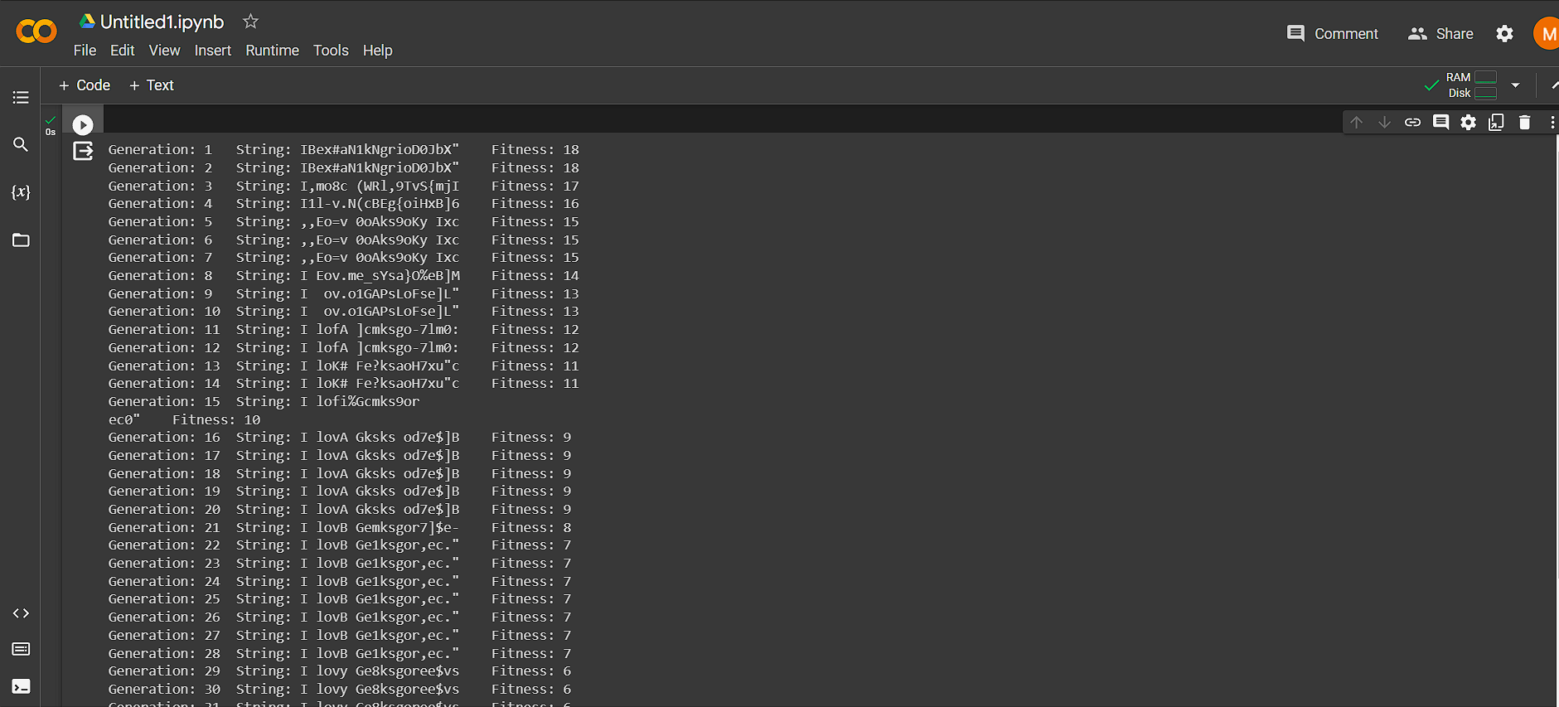

Code 2

import numpy as np

# Define the fitness function to be optimized

def fitness_function(x):

return -x**2 # We want to find the maximum of this function

# Genetic algorithm parameters

population_size = 20

chromosome_length = 5

mutation_rate = 0.1

crossover_rate = 0.8

num_generations = 100

# Generate an initial population with random chromosomes

def initialize_population(population_size, chromosome_length):

return np.random.randint(2, size=(population_size, chromosome_length))

# Decode the binary chromosome to a decimal value

def decode_chromosome(chromosome):

return int(''.join([str(bit) for bit in chromosome]), 2)

# Calculate fitness for each individual in the population

def calculate_fitness(population):

return np.array([fitness_function(decode_chromosome(chromosome)) for chromosome in population])

# Perform single-point crossover between two parent chromosomes

def crossover(parent1, parent2):

crossover_point = np.random.randint(1, len(parent1) - 1)

child1 = np.concatenate((parent1[:crossover_point], parent2[crossover_point:]))

child2 = np.concatenate((parent2[:crossover_point], parent1[crossover_point:]))

return child1, child2

# Perform mutation on a chromosome

def mutate(chromosome):

for i in range(len(chromosome)):

if np.random.rand() < mutation_rate:

chromosome[i] = 1 - chromosome[i]

return chromosome

# Genetic algorithm

def genetic_algorithm(population_size, chromosome_length, mutation_rate, crossover_rate, num_generations):

population = initialize_population(population_size, chromosome_length)

for generation in range(num_generations):

fitness_values = calculate_fitness(population)

# Select parents for crossover

parents = population[np.random.choice(population_size, size=population_size, replace=True, p=fitness_values / np.sum(fitness_values))]

# Perform crossover and mutation

for i in range(0, population_size, 2):

if np.random.rand() < crossover_rate:

population[i], population[i + 1] = crossover(parents[i], parents[i + 1])

population[i] = mutate(population[i])

population[i + 1] = mutate(population[i + 1])

best_individual = population[np.argmax(fitness_values)]

best_value = decode_chromosome(best_individual)

return best_value

# Run the genetic algorithm

best_solution = genetic_algorithm(population_size, chromosome_length, mutation_rate, crossover_rate, num_generations)

print("Best solution found:", best_solution)

print("Fitness value of best solution:", fitness_function(best_solution))

Output

